APACHE KAFKA
Contents
APACHE KAFKA 4
1. Why Kafka exists 4
2. Kafka architecture: core terms 4
Broker and cluster 5
Topic 5
Partitions 5
Message keys 5
Producer 6
Consumer 6
3. Consumer groups 7
Scaling constraint 7
4. Offsets 8
Critical consumer crash scenario 8
5. Delivery semantics 9
At-most-once 9
At-least-once 9
Exactly-once 10
6. Replication and rebalancing 10
Replication 10
Rebalancing 10
7. Why Kafka fits KYT 11
Kafka in the Stridge mental model 11
RELIABLE DISTRIBUTED SYSTEMS 12
8. The dual-write problem 12
Failure case A: DB succeeds, event is lost 12
Failure case B: event succeeds, DB fails 12
9. Transactional Outbox Pattern 12
Does Outbox provide exactly-once publication? 13
10. Idempotent consumers and the Inbox pattern 14
Atomic deduplication 14
End-to-end at-least-once reliability 14
Stridge-style settlement example 15
11. Retry policy 15
Transient failures 15
Permanent failures 15
Exponential backoff and jitter 16
12. Dead-Letter Queue (DLQ) 16
13. Circuit Breaker 17
Retry vs. Circuit Breaker 18
14. Timeouts 18
15. Saga Pattern 18
16. Correlation IDs 19
17. Event ID vs. business ID 19
18. Event versioning 19
19. Complete reliability architecture 20
20. Concrete Stridge-style failure scenario 21
Step 1 - Observer records the deposit 21
Step 2 - Outbox publisher sends the event 21
Step 3 - Settlement consumer creates the settlement 21
Step 4 - Kafka redelivers the event 21
Step 5 - Routing dependency fails 21
Step 6 - Settlement completes 21
Step 7 - Webhook delivery temporarily fails 21
21. What to skip right now 22
22. What to memorize 22
23. Four critical concepts 23
24. Required source reading 23
Must-read 1 - Apache Kafka delivery semantics 23
Must-read 2 - AWS Transactional Outbox 23
Reference sources represented in these notes 23
25. Days 2-3 oral exam 24

APACHE KAFKA
Kafka is not simply a queue; the better mental model is a distributed, durable, ordered event log. Events are retained, and consumers read them at their own pace.
WHY THIS MATTERS FOR KYT: Historical blockchain events can be replayed later through a newer risk model. Kafka's retained event log supports that workflow.

1. Why Kafka exists
Kafka allows producers to publish durable events without knowing every consumer. Different systems can consume the same stream independently, while partitions provide parallelism and ordered processing within defined boundaries.
Deposit Observer
|
| DepositConfirmed
v
Event Broker
/ | \
v v v
KYT Settlement Analytics

Today the event broker in this architecture is Kafka.

2. Kafka architecture: core terms
The fundamental Kafka vocabulary for this stage is: Broker, Topic, Partition, Producer, Consumer, Consumer Group, Offset, Message Key, and Replication.
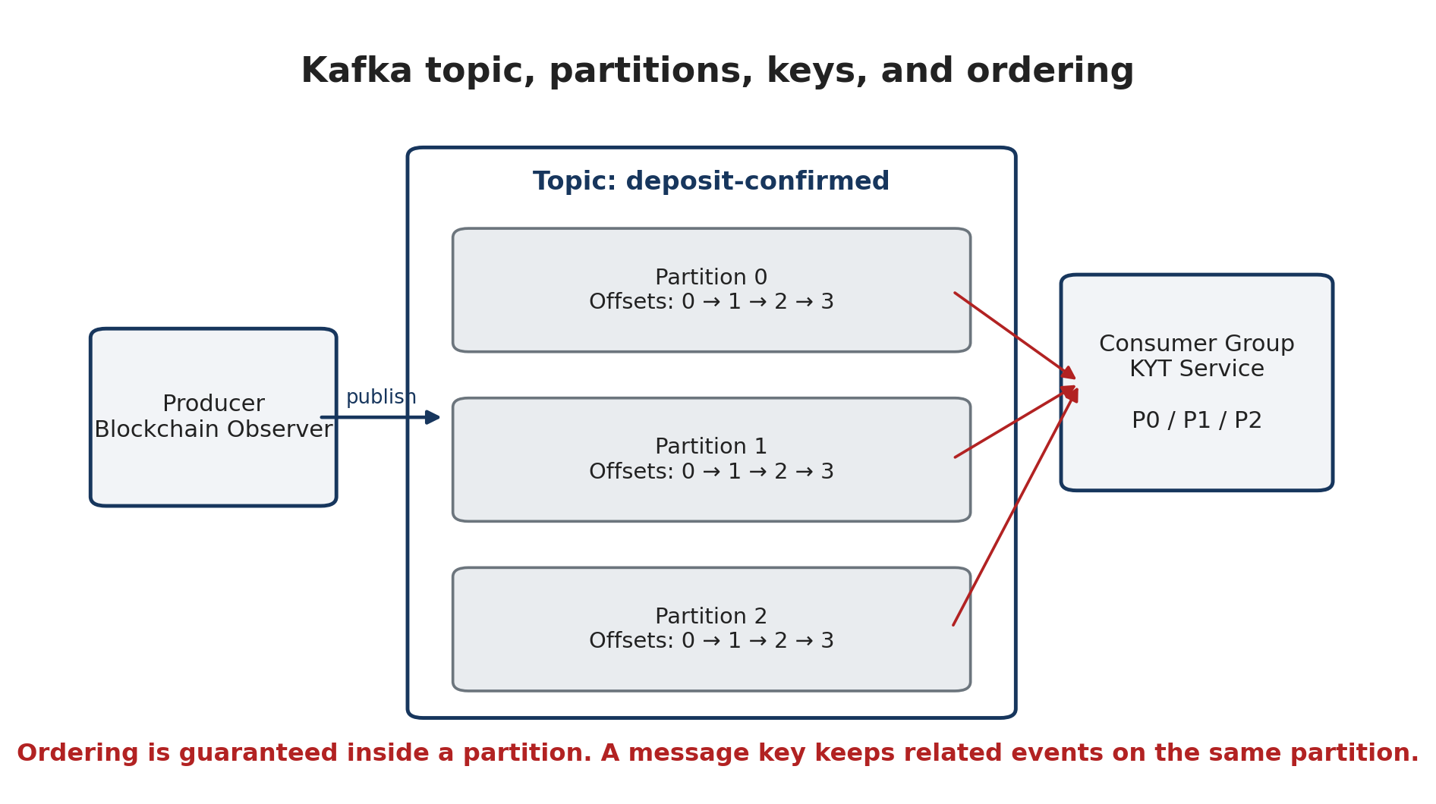
Figure 1. Kafka topics are partitioned. Keys preserve ordering for related events by routing them to the same partition.

Broker and cluster
A broker is a Kafka server. A Kafka cluster contains multiple brokers that collectively host topic partitions and replicas.

Topic
A topic is a named stream of events. In a Stridge-like backend, useful topic names could include:
- deposit.confirmed
- settlement.events
- blockchain.transactions
- kyt.alerts
For example, a topic named deposit-confirmed might retain events such as:
offset 0 -> Alice deposited 100 USDC
offset 1 -> Bob deposited 500 USDT
offset 2 -> Charlie deposited 2 ETH
offset 3 -> Alice deposited another 50 USDC

Kafka stores these events, and consumers can process them independently.

Partitions
A topic is divided into partitions. A single giant ordered stream limits parallelism, while multiple partitions distribute storage/load and allow multiple consumers in one group to process events concurrently.
transactions
Partition 0: 0 1 2 3 4 ...
Partition 1: 0 1 2 3 4 ...
Partition 2: 0 1 2 3 4 ...

VERY IMPORTANT: Kafka guarantees ordering inside one partition. It does not provide one global order across all partitions.

If Partition 0 contains A1 -> A2 -> A3 and Partition 1 contains B1 -> B2 -> B3, Kafka preserves A1 before A2 before A3 and B1 before B2 before B3. It does not guarantee a global relationship such as A2 before B2.

Message keys
A message key determines how related events are assigned to partitions. For example, using wallet_address as the key keeps every event for the same wallet on the same partition, preserving that wallet's event order.
key = wallet_address
0xAlice -> Partition 2
0xAlice -> Partition 2
0xAlice -> Partition 2

Possible keys in a Stridge/KYT system include wallet address, deposit ID, UDA ID, settlement ID, and customer ID. The correct choice depends on which entity requires ordered processing.

Producer
A producer writes events into Kafka. A blockchain observer is a natural producer:
Blockchain Observer
|
v
Kafka

A deposit event could look like:
{
"event_id": "evt_9182",
"type": "deposit.confirmed",
"address": "0xABC...",
"amount": "100000000",
"asset": "USDC",
"tx_hash": "0x..."
}

Stridge's public UDA lifecycle similarly describes a deposit being detected and confirmed before a settlement is opened and eventually completed or failed. This is an educational mapping, not a claim about their private Kafka implementation.

Consumer
A consumer reads events and performs business work. A KYT consumer could receive deposit.confirmed, inspect the wallet, calculate risk, store the result, and publish WalletRiskAssessed.
Kafka
|
| deposit.confirmed
v
KYT worker
1. receive deposit event
2. inspect wallet
3. calculate risk
4. store risk result
5. publish WalletRiskAssessed

Analytics and Settlement can consume the same original event for different purposes.

3. Consumer groups
Consumer groups are the central Kafka scaling abstraction. Multiple worker processes using the same group ID share partitions and therefore share the work.
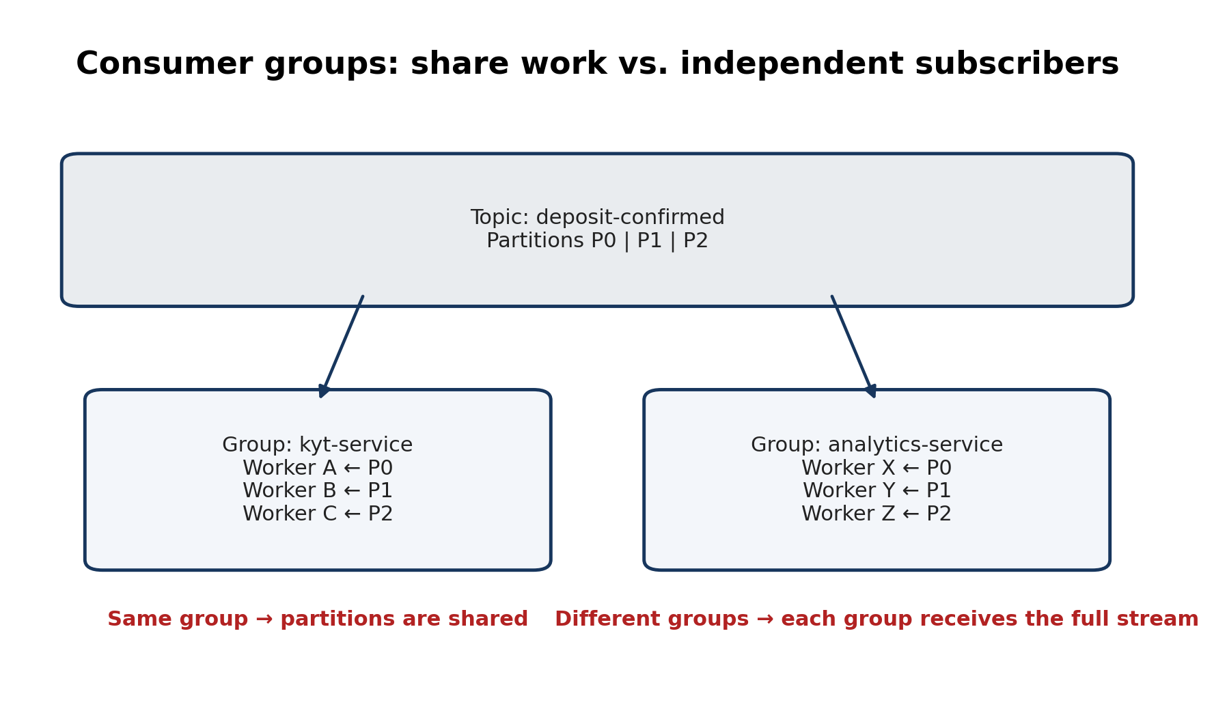
Figure 2. Members of the same consumer group divide partitions. Different groups consume the stream independently.
Within one consumer group, each partition is processed by only one consumer at a time. If Analytics also needs every event, it uses another consumer group.
RULE: Same consumer group -> workers share the work. Different consumer groups -> each group receives the event stream independently.

Scaling constraint
If a topic has three partitions and the KYT consumer group has three consumers, each can own one partition. Adding a fourth consumer does not create more useful parallelism; it remains idle because one group cannot actively assign one partition to multiple members at the same time.
P0 -> C1
P1 -> C2
P2 -> C3
C4 -> idle

PRACTICAL LIMIT: Within one consumer group, useful parallelism is limited by the topic's partition count.
For example:
topic: deposit.confirmed
we put each users deposit with a uda_id key so that each user’s events are in the same partition. Why? Because we want each user’s events to be ordered.

4. Offsets
Each event in a partition has an offset, which is its position in that partition. Consumer groups commit offsets to record how far they have successfully processed.
Partition 0
offset 0 -> Deposit A
offset 1 -> Deposit B
offset 2 -> Deposit C
offset 3 -> Deposit D

If a consumer has successfully processed through offset 2, it can commit that position so a restarted consumer knows where to resume.

Critical consumer crash scenario
A consumer can successfully create an external side effect and crash before committing the offset:
1. Read event 500
2. Calculate risk score
3. INSERT risk score into database
4. CRASH
5. Offset 500 was never committed

Kafka therefore considers event 500 unfinished. After restart it can redeliver event 500, which can repeat the database operation.
VERY IMPORTANT: Kafka consumers must often be idempotent because successfully processed records can be delivered again.

5. Delivery semantics

At-most-once
At-most-once can commit the offset before business processing. If the consumer crashes after the commit but before processing, Kafka considers the record complete even though the business action never happened.
commit offset
|
v
process message
Crash after commit -> work may be lost

The result is: work may be lost, but the same record is not intentionally processed twice.

At-least-once
At-least-once processes first and commits the offset after successful business work. If the business action succeeds and the process crashes before committing, the record is delivered again.
process
|
success
|
commit offset
Crash before commit -> duplicate processing possible

The result is: no intentional loss of retained work, but duplicates are possible. For financial infrastructure this is often preferable when consumers are designed to be idempotent.

Exactly-once
Kafka can provide strong exactly-once semantics for transactional workflows contained within Kafka, where input offsets and Kafka outputs can be coordinated. That guarantee does not automatically extend to PostgreSQL, external AML APIs, email, blockchains, or every other external side effect.
Kafka
|
KYT Consumer
|
PostgreSQL
|
external AML API
|
email

PROFESSIONAL RULE: Do not chase magical 'exactly once everywhere.' A common practical design is at-least-once delivery plus idempotent processing.

A good answer to 'Does Kafka guarantee exactly-once processing?' is: Kafka supports exactly-once semantics within Kafka transactional workflows, but once processing involves external databases or APIs, the end-to-end guarantee depends on those systems too. Many backend systems therefore design for at-least-once delivery and idempotent consumers.

6. Replication and rebalancing

Replication
Kafka can replicate a partition across brokers for fault tolerance. One broker hosts the leader, while other brokers hold replicas. If the leader broker fails, another replica can take over.
Partition 0
Broker 1: Leader
Broker 2: Replica
Broker 3: Replica

DISTINCTION: Partition = unit of ordering and parallelism. Replica = redundancy and fault tolerance.

Kafka replication configuration is not part of the current study target; the goal is to understand why replicas exist.

Rebalancing
When consumers join or leave a group, Kafka can reassign partitions. If Consumer B dies, another group member can inherit B's partition. If a new consumer joins, partitions can be redistributed.
Before:
A -> P0 P1
After B joins:
A -> P0
B -> P1

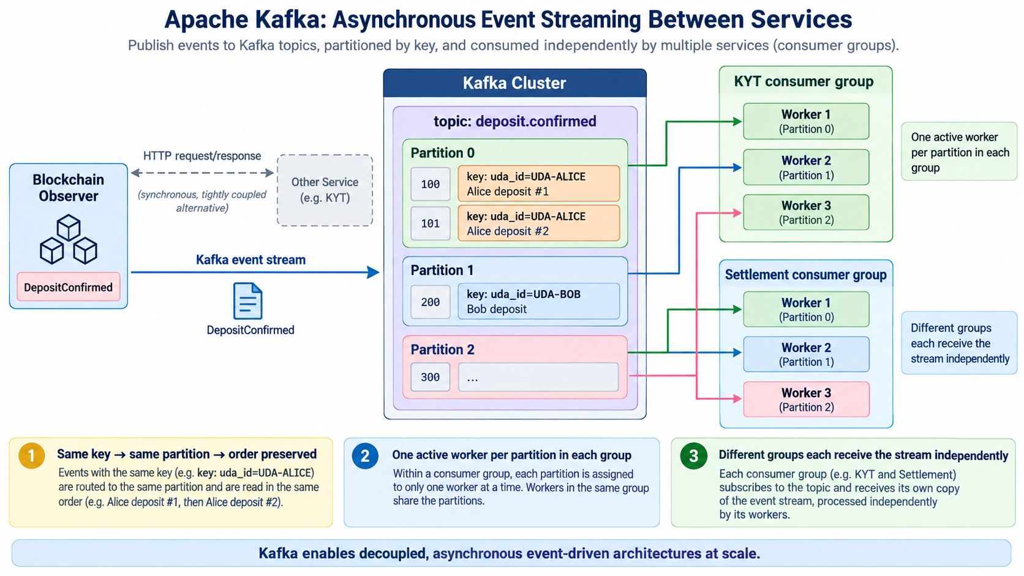
This reassignment process is a rebalance. Internal Kafka rebalance protocols are not required now; understand only the purpose.

7. Why Kafka fits KYT
A KYT platform naturally has several independent consumers of blockchain data: real-time risk scoring, data-lake archival, analytics, and later model retraining.
Blockchain indexers
|
v
Kafka topic: transactions
|
------------------------------------
| | |
v v v
KYT realtime Data lake Analytics
consumer sink

Later, a new model can process historical events again. This retained, replayable stream is why Kafka fits data pipelines better than forcing every internal purpose through a synchronous POST /kyt call.

